

Topic test 2
Name: __________________________________

Chapter 2: Sets and basic probability

• Time allowed: 45 minutes
• CAS calculators may be used.
• Part A: 5 multiple-choice questions (5 marks)
• Part B: 7 short answer questions (31 marks)
• Part C: 2 analysis questions (14 marks)
Part A
5 multiple-choice questions
1 mark each: 5 marks
Circle the correct answer.
1 A = {odd multiples of 5 less than 50}, B = {multiples of 3 less than 50}. A  B =
A {5, 6, 9, 12, 15, 18, 21, 24, 25, 27, 30, 33, 35, 36, 39, 42, 45, 48}
B {5, 15, 25, 30, 35, 45}
C {5, 15, 25, 35, 45}
D {9, 15, 21, 27, 33, 39, 45}
E {15, 45}

[1 mark]
2 Three bags each contain a red, green and blue marble. Which of the following is the sample
space for drawing a coloured marble from each bag? Note that R = red, G = green, B = blue.
A {R, G, B, R, G, B, R, G, B}
B {RGB, RGR, RGG, RBB, RBR, RBG, RRR, RRB, RRG, BGB, BGR, BGG, BBB, BBR, BBG,
BRR, BRB, BRG, GGB, GGR, GGG, GBB, GBR, GBG, GRR, GRB, GRG}
C {RGB, RBG, BGR, BRG, GBR, GRB}
D {RGB, RGR, RBR, RBG, BGB, BGR, BRB, BRG, GBR, GBG, GRB, GRG}
E {RGR, RBB, RRG, GBR, GRB, GGR, BRB, BGB, BRG, RGR, RBG, RRB, GBR, GRG, GGR,
BRG, BGG, BRR}

[1 mark]
3 For the sample space for throwing two eight-sided dice numbered 1 – 8, n(total = 10) =
A 7
B 10
C 8
D 6
E 9

[1 mark]
4 The probability that a card drawn from a normal pack is a picture card or ace is
A 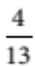
B 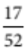
C 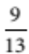
D 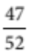
E 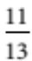

[1 mark]
5 The Venn diagram that shows the set (A  B )  (A  C )  (B  C ) is:
A 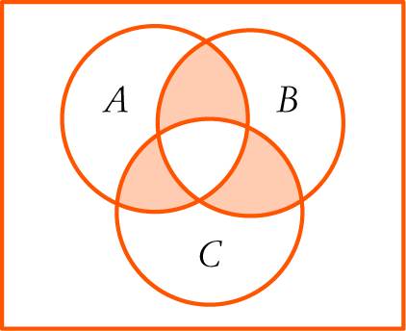 B 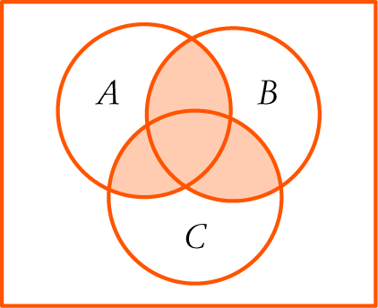 C 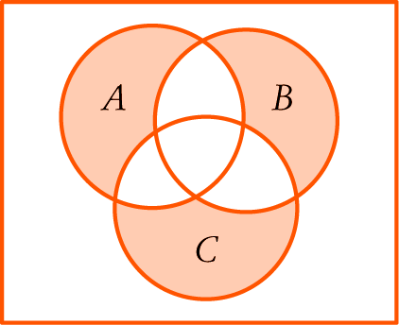
D 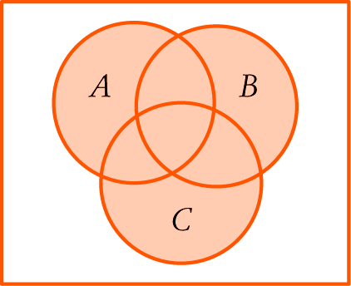 E 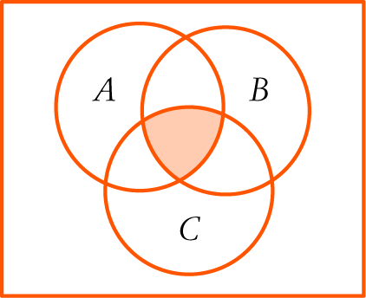
[1 mark]

Part B
7 short answer questions
31 marks
Show your working where appropriate.
1 There are 14 acrylic and 16 wool blankets in a storeroom at a camping facility. 5 of the blankets
are red, 8 are blue and the rest are grey. 3 of the blankets are red wool ones and 4 are acrylic grey
ones. All the blankets are wool or acrylic. If a blanket is chosen at random, find the probability
that it is:
a a grey woollen blanket

b a blue acrylic blanket.

[4 marks]
2 Write the following sample spaces.
a The sample space for selecting a person native to one of the continents of the world.

b The sample space for choosing two different colours from red, black, yellow, green and white.

[5 marks]
3 What are the sample space and probabilities for finding the sum of two numbers, each chosen
at random from 2, 3, 4, and 5?

[6 marks]
4 A car yard has 3 Holdens, 5 Fords, 3 Toyotas, 2 Nissans, a Honda and a BMW for sale.
Work out the probability of each car being sold next, assuming that there is no way of
knowing what the next customer wants.

[3 marks]
5 A greengrocer keeps trays of stone fruit in the cool store behind his shop. The probabilities,
to two decimals, of choosing trays of peaches, nectarines and apricots are 0.42, 0.17 and 0.17 respectively.
There are 30 trays of cherries, the other stone fruit they keep. How many trays of apricots are there?

[7 marks]
6 40 people out of the 250 interviewed in a shopping centre said they came in to take advantage
of the air conditioning and were not going to buy anything. The others interviewed said they
did intend to get something. What is the probability that randomly selected person selected is
in the shopping centre just for the air conditioning? Estimate the number of people from the
3700 in the centre who do not intend to buy anything.

[3 marks]
7 In northern Africa, about 20% of the population have sickle-cell characteristics and 25% have
attached ear lobes. About 5% have both attached ear lobes and sickle-cell characteristics.
What is the probability that if you choose a northern African at random, the person will have
either attached ear lobes or sickle-cell characteristics?

[3 marks]
Part C
2 analysis questions
14 marks
Show your working where appropriate.
1 A card table 600 mm square is covered by cork tiles and divided into four squares by wide stripes as shown in the diagram.
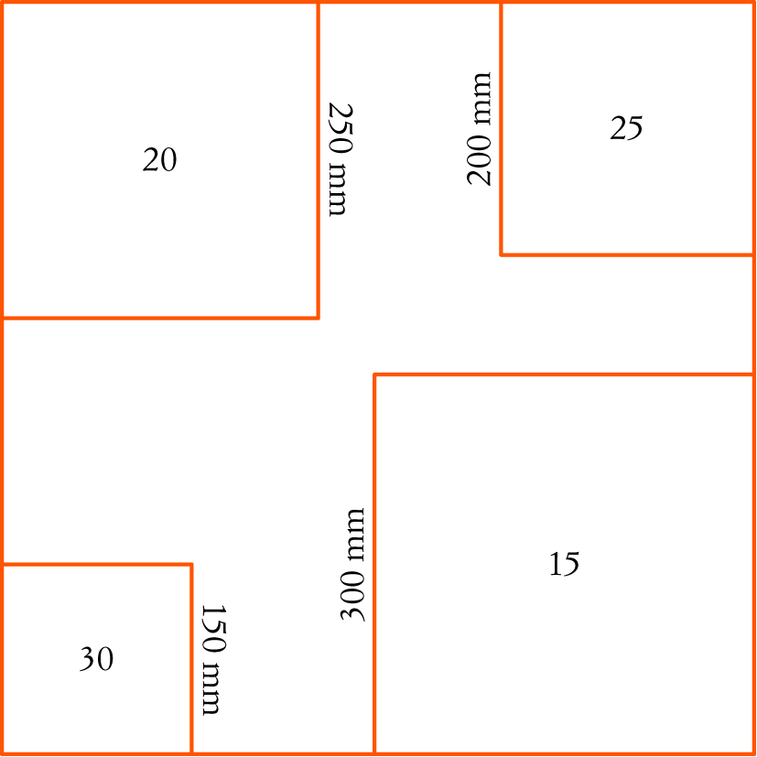
Darts are thrown towards the table from a distance of 2 metres. Those landing in the marked squares score the points shown in them, but those landing in the stripes score nothing. What are the sample space and probabilities for the scores? Assume that all darts stick into the cork on the table.

[7 marks]
2 50 students do at least one of Chemistry, History and Art, but none of them take all three. 26% do Art, 44% do History and 34% do Chemistry. 8 students take History and one of either Art or Chemistry. The probability of choosing a student doing both Chemistry and Art is only 0.04. What is the probability of choosing a student at random who does none of these subjects?

[7 marks]
Total marks: 50
Answers
Part A [1 mark each]
1 A = {5, 15, 25, 35, 45} and B = {3, 6, 9, 12, 15, 18, 21, 24, 27, 30, 33, 36, 39, 42, 45, 48}
so A  B = { 15, 45}.
 E [1 mark]
2 For R first, the second can be R, G or B. The third can also be R, G or B. This applies and G and
B first as well. So the sample space is:
{RGB, RGR, RGG, RBB, RBR, RBG, RRR, RRB, RRG, BGB, BGR, BGG, BBB, BBR, BBG, BRR,
BRB, BRG, GGB, GGR, GGG, GBB, GBR, GBG, GRR, GRB, GRG}.
 B [1 mark]
3 The event, ‘total = 10’ = {28, 37, 46, 55, 64, 73, 82}, so n(total = 10) = 7.
 A [1 mark]
4 n(picture card) = 12, n(ace) = 4 and n(picture card and ace) = 0,
so n(picture card or ace) = 12 + 4 = 16. Thus P(picture card or ace) 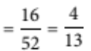
 A [1 mark]
5 This can be done step-by-step using three diagrams. Draw Venn diagrams for (A  B ), (A  C )
and (B  C ).
Then (A  B )  (A  C )  (B  C ) is just the combination of the three areas. The problem can also
be solved with just one diagram by shading in the areas for (A  B), then (A  C ), then (B  C ).
 B [1 mark]
Part B
1 a There are 17 grey blankets and 4 are acrylic so 13 are wool, so P(grey wool) 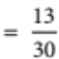 [2 marks]
b There are 3 red and 13 grey woollen blankets so none of the wool ones are blue.
Thus P (blue acrylic) 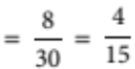 [2 marks]
[4 marks]
2 a {African, European, Australian, North American, South American, Asian} [2 marks]
b {RB, RY, RG, RW, BY, BG, BW, YG, YW, GW} [3 marks]
[5 marks]
3 S = {2 + 2, 2 + 3, 2 + 4, 2 + 5, 3 + 2, 3 + 3, 3 + 4, 3 + 5, 4 + 2, 4 + 3, 4 + 4,
4 + 5, 5 + 2, 5 + 3, 5 + 4, 5 + 5} [2 marks]
P (4) = 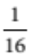, P (5) = , P (6) = 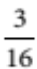, P (7) = , P (8) = , P (9) = , P (10) = [4 marks]
[6 marks]
4 P (Holden) = , P (Ford) = , P (Toyota) = , P (Nissan) = 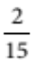, P (Honda)= 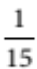,
P (BMW) = [ mark each]
[3 marks]
5 P (cherries)
= 1 – (0.42 + 0.17 + 0.17) [1 mark]
= 0.24 [1 mark]
0.24 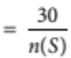 [1 mark]
so n(S ) = 125 [1 mark]
n(apricots) = 0.17 × 125  21 [1 mark]
There are 21 trays of apricots. [2 marks]
[7 marks]
6 P (air conditioning) 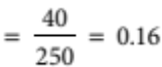 [1 mark]
Expected number from 3700 = 0.16 × 3700 = 592 [1 mark]
The probability that a person is just using the air conditioning is about 0.16 and this
would apply to about 592 of the people in the centre. [1 mark]
[3 marks]
7 Use P (A or B) = P (A) + P (B) – P (A and B)
P(attached or sickle-cell)
= P (attached) + P (sickle-cell) – P (attached and sickle-cell)
= 0.2 + 0.25 – 0.05 [1 mark]
= 0.4 [1 mark]
The probability that a northern African person will have either attached ear lobes or sickle-cell
characteristics is 40%. [1 mark]
[3 marks]
Part C
1 Assume that the probabilities are proportional to the areas and the darts land in the cork.
Area (20) = 250 × 250 = 62 500 cm2
Area (25) = 200 × 200 = 40 000 cm2
Area (30) = 150 × 150 = 22 500 cm2
Area (15) = 300 × 300 = 90 000 cm2
Total area = 600 × 600 = 360 000 cm2
Area (0) = 360 000 – (62 500 + 40 000 + 22 500 + 90 000) = 145 000 [1 mark]
Then S = {0, 15, 20, 25, 30} [1 mark]
P(0) 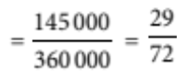
P(15) 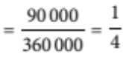
P(20) 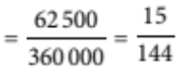
P(25) 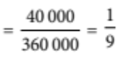
P(30) 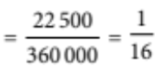 [1 mark each]
[7 marks]
2 13 do Art, 22 do History and 17 do Chemistry. [1 mark]
Number of students taking both Chemistry and Art = 0.04 × 50 = 2. [1 mark]
Assume that the number doing History and Art is n. [1 mark]
Complete a Venn diagram and fill in the numbers.
Using the diagram, the number doing at least one,
n(at least one) = 14 + 8 – n + n + 15 – n + 2 + n + 3
= 42 [1 mark]
[Diagram 2 marks]
Thus P (none of these subjects) 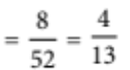 = 0.16 or 16%. [1 mark]
[7 marks]

